Quarterly Macro Fiscal Outlook─Sept 2024 Forecast: Summary input for intMF (Dec.7, 2024)
1. real GDP is forecast to slow down markedly in 2025-26, well below potential growth, followed by a catch-up (a bit above potential) in 2027-28, before returning to the regular growth path of 7½%.
GDP growth in 2024 is forecast at 8% despite a slowdown to 5% in the last Q, given robustness earlier in 2024. Growth so far in 2024 was helped by still low RIR (see 6.) and still modest fiscal restraint.
The slowdown in 2025-26 is driven by:  - contractionary effect of strong fiscal consolidation, both directly as govt demand for G&S falls, and indirectly through the negative fiscal impulse on private demand  - negative impact on demand of increased RIR and real lending rates returning to normal (see 6.)  - slightly offsetting positive, but lagged effect on net exports of recent & ongoing RER depreciation | Chart 1a. GDP, y-on-y growth in %  GDP growth below trend 2025-26, pick-up in 2027… 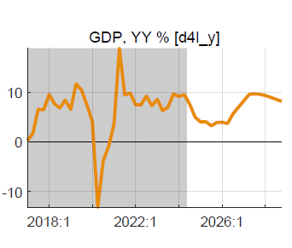
The catch up in 2027-28 is driven by:  - end of fiscal consolidation, the negative fiscal impulse stops  - end of increase and start of slight decrease in RIR and real lending rates  - positive impact of more depreciated RER (some undervaluation) | Chart 1b. GDP (log(level) vis-a-vis trend)  …and by 2028 return to trend  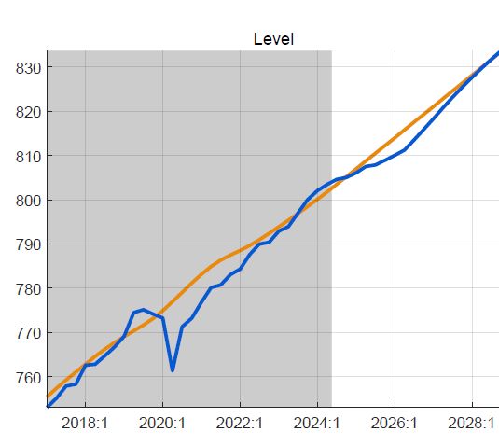
Input for intMF projection GDP growth p.a.: 2024: 8%, 2025: 5%; 2026: 6%, 2027-28: 8-9%, 2029: 7.5%

2. CPI is forecast to be subdued below 5% through 2027, followed by a gradual return to target 5%
The y-o-y and period average CPI in 2024 is forecast at below 5%, helped by the recent drop in food prices, reversal in 2023-24 of the earlier positive price shocks, and the expectation of lower inflation thanks to demand-restraining policies.
The CPI well below 5% in 2025-27 is driven by:  - effect of increasing RIR and large negative fiscal impulse on demand, hence on output  - continued drop in food prices as agriculture is returning to normal  - still low trading partner prices, and small drop in world energy and food prices  - somewhat offset by the CPI-increasing effect of NER depreciation on import prices | Chart 2a. Headline CPI, y-on-y growth in %  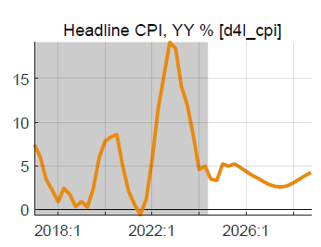
The return to the target CPI from 2028 onward is driven by:  - govt demand pick up as consolidation stops post-PCI  - other demand components return to normal  - interest rate policies push inflation back to target | Chart 2a. CPI_core , y-on-y growth in %  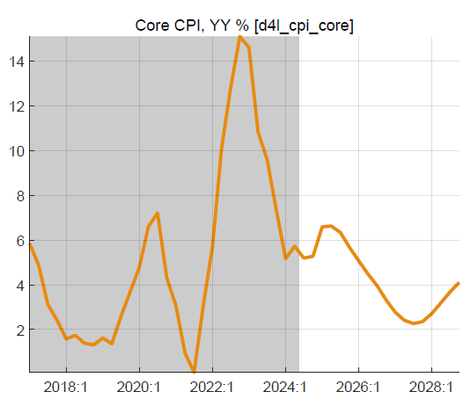
==>for intMF projection CPI p.a.: 2024: 4%, 2025: 5%; 2026: 4%, 2027: 3%, 2028: 4%.

3. Final demand: private demands forecast to slow down in 2025-26, returning to normal thereafter
Real consumption: after above-trend growth (low RIR) in 2023/early 2024, restrictive policies reduce real consumption growth to +4% in 2025-26, before it returns to trend growth in line with GDP (7.5%) | 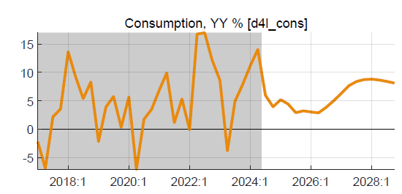
Real investment: after sluggish growth in 2022-23, growth is forecast to be strong in 2024 (above 10%), slowing down to +6% in 2025-26 as real lending rates increase; then moving to trend growth | 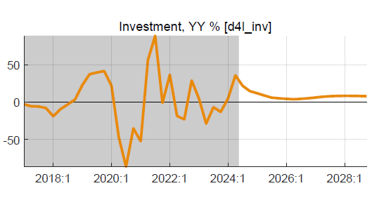
Real govt demand: almost no growth in 2025-26 due to fiscal consolidation, strong pickup thereafter | 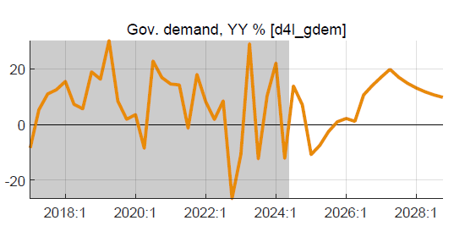
Real exports: after above trend growth in 2023-24, export growth slows down but gradually since the positive effect of recent RER depreciation keeps export growth above trend for the whole period | 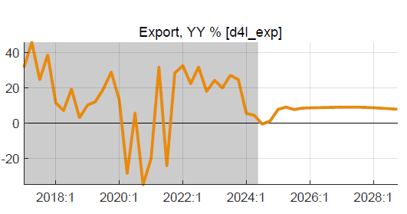
Real imports: follow other demand components (including govt demand). | 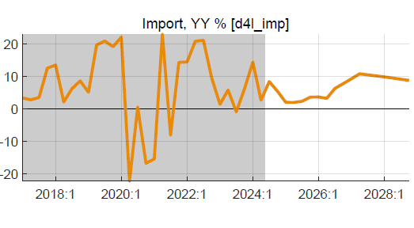
==>for intMF projection: adjust exogenous investment growth and revisit export & import projections, while ensuring that growth of private consumption (residual) is in line with QMFM forecast.
4. Fiscal path assumed: PCI targets FY2024/25-2025/26 for deficit, revenue, and spending are used
Baseline fiscal policies are as in PCI 2023/24-2025/26, followed by a return to the previous path of gradually moving toward a sustainable deficit of 5% of GDP (7.5% excl. grants) rather than 3% as in post-PCI IMF projection. This note deems such a path preferable to excess consolidation.
- negative govt demand and fiscal impulse entail slowdown of output growth in 2025-26
- from late 2026, negative fiscal impulse ends, deficit moves back up toward sustainable path
- beyond-PCI, fiscal ratios move to sustainable levels: rev/GDP 24%, govt dem G&S 26%, other exp 5.5%, grants 2.5%, and debt-creating deficit 5% GDP (consistent with 45% NPV public debt)
- esp. as revenue is slow to rise, debt-creating deficits are 7% for a few years, above sustainable
Chart 4. Fiscal aggregates (2024/25-2025/26 PCI)
Budget deficit (before grants, GFS1986)  Significant drops in deficits 2024-26 reflect …. | Government demand for G&S vis-à-vis trend  ..below-trend govt demand for G&S (direct demand effect)...
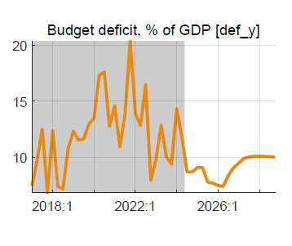 | 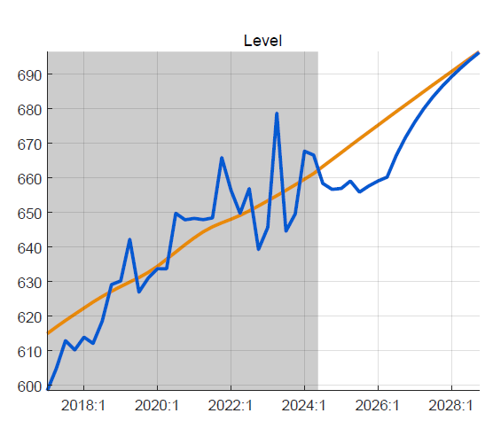
Government revenue, % of GDP, vis-à-vis trend  …and strong upturn in govt revenue…. | Fiscal impulse (discr. def. & change structural def.)  entailing negative fiscal impulse on private demand (indirect)
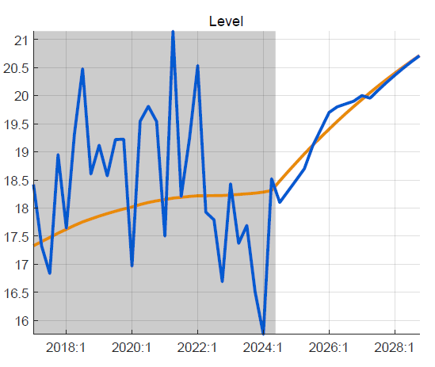 | 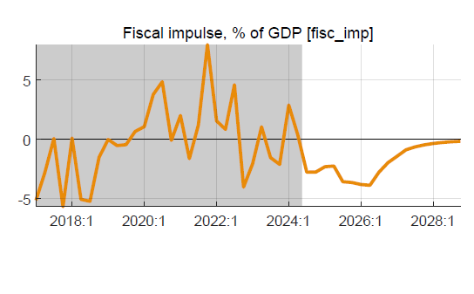
==>for intMF: revisit post-PCI fiscal path, in line with gradual move to sustainable debt & deficit levels
5. Exchange rate (ER): returns gradually to path of only correcting for inflation differentials (3% py)

- recent real overvaluation (mostly from 2022-23 inflation episode) has already been more than corrected with NBR's 2023-24 steep depreciation and resulting RER depreciation  - QMFM projects return to ER policy rule (mostly moving with inflation differentials), with no need for further RER depreciation  - PCI, instead, "poses" lingering overvaluation of 15% (which evidence?) requiring more depreciation, as built into PCI projection for 2024-28 | Chart 5a. Real exchange rate and trend (log-levels)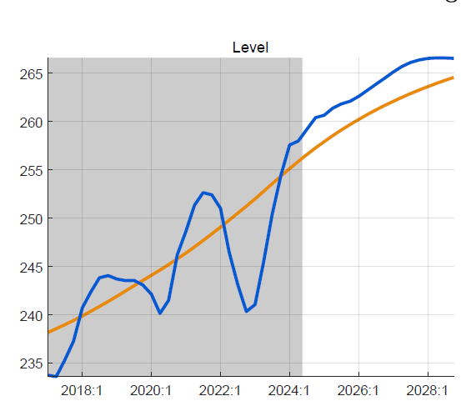
Chart 5b. Nominal exchange rate, y-on-y growth in %  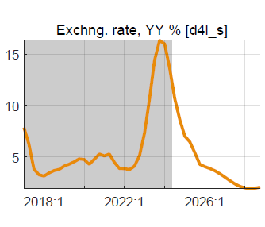 | Chart 5c. Real exchange rate, y-on-y growth in %  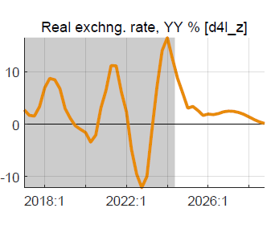
==>for intMF: ER depreciation can slow down, with less need for intervention (note that RSF and SCF should not be excluded from reserve coverage, nonsensical esp. as all RSF is channeled to budget)

6. RIR lending rate: expected to go back up to normal (+12%, for 8% premium above RIR-Interbank (IB), but stay above pre-Covid level as world RIR rises to reach 1.5% (from negative in recent years)
- during most of 2022-24, RIR lending rates have been low (below trend), thus stimulating demand,  - they were rising in recent quarters (as inflation fell), lessening their demand-stimulating effect  - in 2025-26, their return to normal (around 12%) should end their demand-stimulating effect | Chart 6a. Real lending rate, deviation from trend % 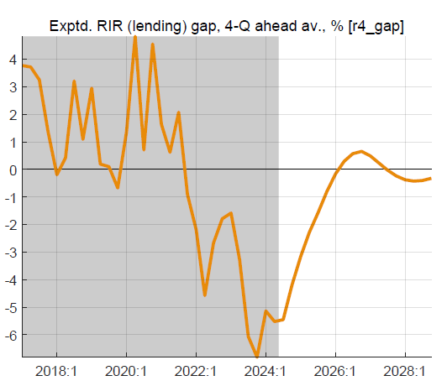
- real lending rates mirror the real policy rate (RIR-IB) through a transmission mechanism | Chart 6b. Real policy interest rate (IB) and trend  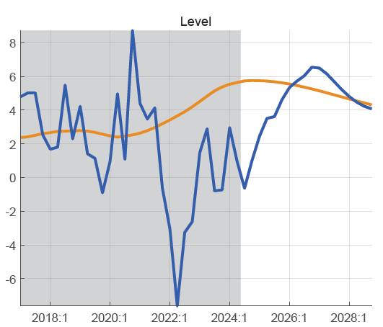
- the neutral policy (IB) rate—after a temporary drop with low inflation—is expected to go up to 8.5-9% (and 4-4.5% in real terms) as world RIR increase and CPI inflation returns to target  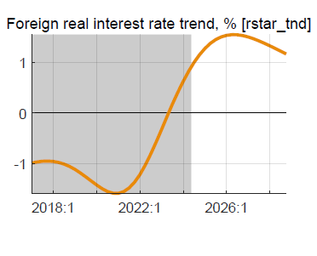 | Chart 6c. Policy rate (IB) and neutral rate, %  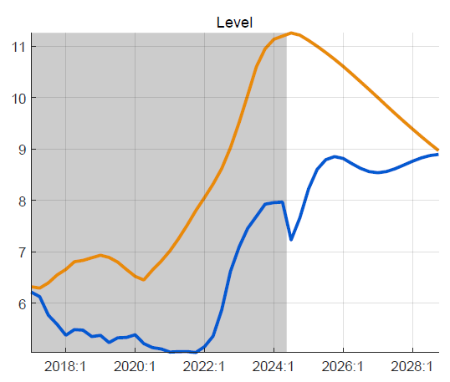

Table 1. Key macro aggregates, annualized
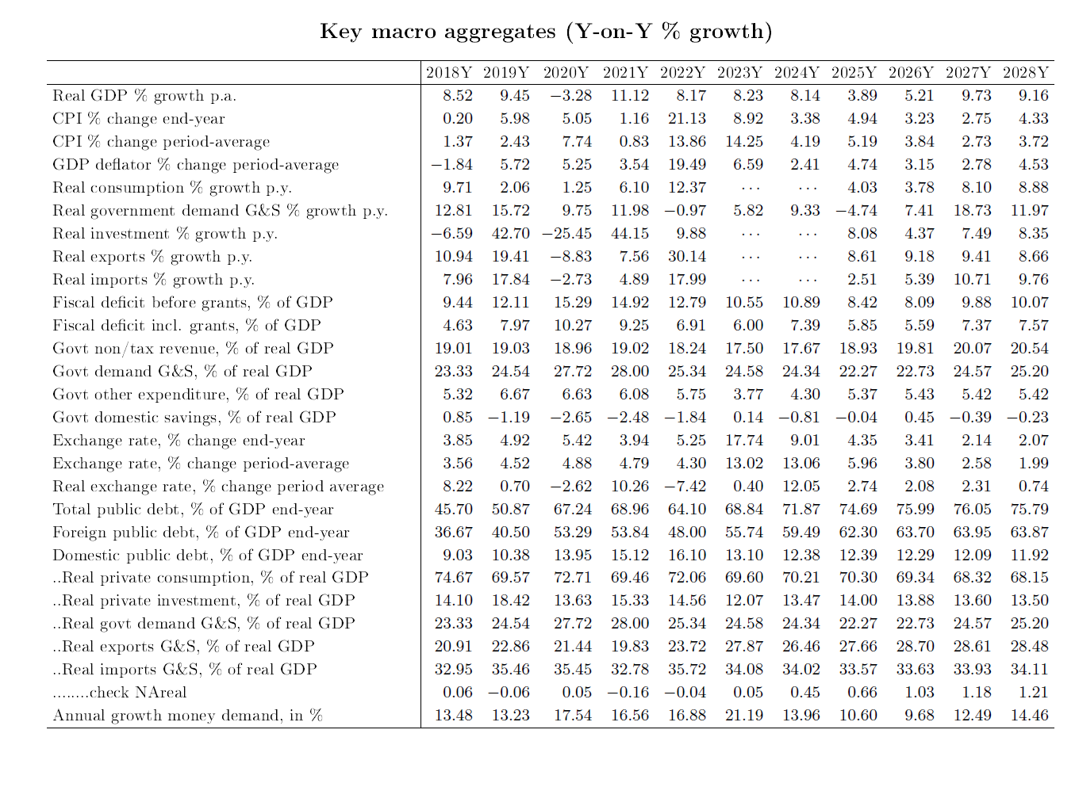
1/ Reliable NA data are missing for final demands for 2023Q3-2024Q2, and replaced by model estimates in forecast.

A debt-creating deficit of 5% of GDP corresponds—under realistic assumptions on growth, trading partner CPI, share of domestic debt, concessionality external debt—to sustainable NPV debt-GDP ratio of 45%, below IMF-DSF’s ceiling of 55%.
An alternative fiscal scenario, with post-PCI fiscal targets as in program FISCAL, shows unrealistic leaps in revenue, an even larger GDP growth slowdown effect, and an even sharper drop in debt/GDP than the Baseline.
The neutral policy interest rate comprises target inflation and trend RIR, which consist of world RIR, country risk premium, and expected RER depreciation. In the forecast period, the latter pushes up the neutral rate by about 2% points.

